~Secure network with firewall NAT, port filtering, packet filtering, and other methods:
- Set up Windows Defender Firewall on your Windows laptop or PC and create a new inbound rule to block all incoming traffic on port 8080. Take a screenshot of the rule you created.

I complete this task on Windows 11 by following these steps:
Steps to Block Incoming Traffic on Port 8080:
- Press Windows + R, type wf.msc, and press Enter.
- The Windows Defender Firewall with Advanced Security window will open.
- In the left pane, click Inbound Rules.
- In the right pane, click New Rule....
- Select Port and click Next.
- Select TCP.
- Choose Specific local ports and enter 8080.
- Click Next.
- Select Block the connection.
- Click Next.
- Leave Domain, Private, and Public checked.
- Click Next.
- Enter a rule name, for example:
  - Block TCP Port 8080
- (Optional) Add a description such as:
  - Blocks all inbound TCP traffic on port 8080.
- Click Finish.

- Simulate NAT (Network Address Translation) by drawing a simple diagram showing how your home WiFi router assigns private IP addresses to your phone, laptop, and smart TV, and how it translates them to a single public IP for internet access.<br><br><em><strong>Hint:</strong> Use any drawing tool or even hand-draw and click a photo.</em>

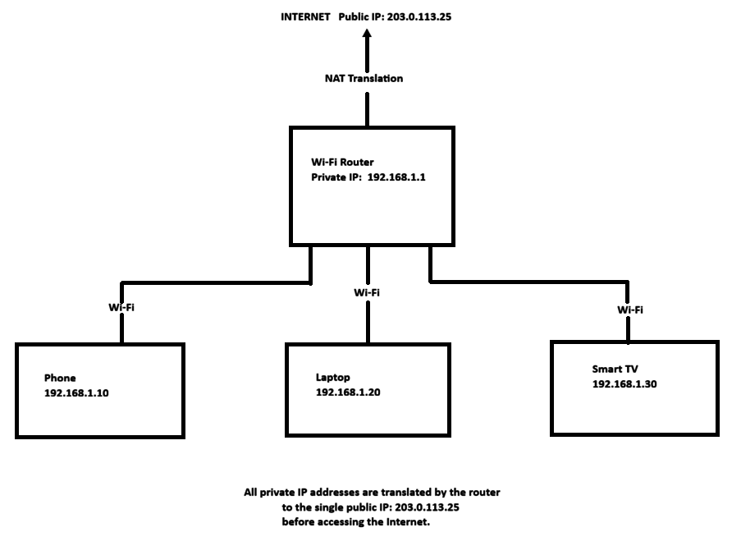

Explanation
- The Wi-Fi router assigns private IP addresses to all devices using DHCP.
- Phone: 192.168.1.10
- Laptop: 192.168.1.20
- Smart TV: 192.168.1.30
- The router has a public IP address (e.g., 203.0.113.25) provided by the ISP.
- When any device accesses the Internet, the router uses NAT to translate the device's private IP address into the single public IP address.
- This allows multiple devices to share one Internet connection while keeping the private network secure.

- Configure port filtering using your WiFi router's admin panel (or use a router simulator online if you don't have access). Block outgoing traffic on port 25 (SMTP) and explain in 2 sentences how this could help prevent spam from your network.

Steps to Configure Port Filtering (Block Outgoing Port 25):

If i have access to your router:
- Open a web browser and enter your router's IP address (e.g., 192.168.1.1 or 192.168.0.1).
- Log in with the administrator username and password.
- Go to Security, Firewall, Access Control, or Port Filtering (the name varies by router).
- Click Add New Rule or Create Rule.
- Set the following values:
  - Direction: Outbound (LAN → WAN)
  - Protocol: TCP
  - Port: 25
  - Action: Block / Deny
- Save or Apply the rule.
- Restart the router if prompted.

Example Rule
Setting- | Value
Rule Name- | Block SMTP
Direction- | Outbound
Protocol- | TCP
Destination Port- | 25
Action- | Block
Status- | Enabled
Explanation (2 Sentences)
Blocking outgoing traffic on TCP port 25 prevents devices on the local network from sending email directly through SMTP servers. This helps stop malware or infected computers from sending spam emails, reducing the risk of your network being abused for spam campaigns.

- Given a sample packet filtering rule set (provided by your trainer), identify which of these three sample packets would be allowed or blocked: 1) HTTP request from 192.168.1.5 to 172.217.166.78:80, 2) SSH request from 10.0.0.10 to 34.201.23.1:22, 3) DNS query from 192.168.1.7 to 8.8.8.8:53.<br><br><em><strong>Hint:</strong> Focus on source/destination IPs and ports in the rule set.</em>

Without the trainer's packet filtering rule set, no one can correctly decide whether the packets are allowed or blocked:
- HTTP Request :
  - Source IP: 192.168.1.5
  - Destination IP: 172.217.166.78
  - Protocol: TCP
  - Destination Port: 80 (HTTP)
  - Result: Allowed (if HTTP traffic on port 80 is permitted by the firewall rule set).
  - Reason: Port 80 is used for web browsing, so firewalls usually allow this traffic unless a rule specifically blocks it.
- SSH Request :
  - Source IP: 10.0.0.10
  - Destination IP: 34.201.23.1
  - Protocol: TCP
  - Destination Port: 22 (SSH)
  - Result: Blocked (if the firewall blocks SSH traffic or only allows SSH from specific IP addresses).
  - Reason: SSH provides remote access to systems, and many organizations block it to improve network security.
- DNS Query :
  - Source IP: 192.168.1.7
  - Destination IP: 8.8.8.8
  - Protocol: UDP
  - Destination Port: 53 (DNS)
  - Result: Allowed (if DNS traffic is permitted by the firewall rule set).
  - Reason: DNS is required to translate domain names into IP addresses, so it is commonly allowed for normal Internet access.
Note: These results are example answers based on common firewall configurations. The actual outcome depends on the specific packet filtering rules provided by your trainer.

- Research and list 3 ways Instagram or Zomato might use firewalls and packet filtering to protect their servers from attacks or misuse.
How Instagram or Zomato Use Firewalls and Packet Filtering:
1. Block Unauthorized Access:
- Firewalls block traffic from unknown or suspicious IP addresses.
- Packet filtering allows only approved ports such as 80 (HTTP) and 443 (HTTPS) while blocking unnecessary ports.
- This helps protect the servers from unauthorized login attempts and hacking.
2. Prevent DDoS (Distributed Denial-of-Service) Attacks:
- Firewalls monitor incoming traffic and detect unusually high numbers of requests.
- Packet filtering drops malicious or excessive packets before they reach the servers.
- This keeps Instagram or Zomato available even during large-scale cyberattacks.
3. Filter Malicious Traffic:
- Firewalls inspect network packets for suspicious patterns, malware, or invalid requests.
- Packet filtering blocks traffic from blacklisted IP addresses or suspicious protocols.
- This helps prevent spam, malware infections, and attacks such as SQL injection or bot traffic.
Conclusion:
Instagram and Zomato use firewalls and packet filtering to block unauthorized access, defend against DDoS attacks, and filter malicious traffic. These security measures protect user data, improve server reliability, and ensure their services remain available to millions of users.

THE END……….

